

Information Sessions on

the New Japanese-Language Proficiency Test

**2010からが**

**しくなりました。**

MC900079190[2]

Since 2010, the JLPT has made some

changes with increased focus on

communicative competence, which is

reflected in the form of some of the

questions. In addition, the number of levels and the scoring system

have been changed. You can learn more about the new JLPT at <http://jlpt.jp/e/about/index.html> . You can also try some sample

questions of each level by visiting <http://jlpt.jp/e/samples/forlearners.html> .

However, it is often helpful to have someone explain and/or to try sample

questions together with others who are preparing for the same exam.

Therefore, we are offering the following information sessions to help

examinees (1) to understand the changes in the new JLPT and

(2) to become acquainted with the new types of questions.

Location: The Japan Foundation, Toronto

131 Bloor St W, Suite 213, Toronto (2nd floor of the Colonnade)

Dates and Times: (N1-N3: 2-day session, N4-N5 1-day session)

**JLPT N1** Information Sessions **8/15, 22** (Mondays 7:00 – 8:30)

**JLPT N2** Information Sessions **8/19, 26** (Fridays 6:30 – 8:00)

**JLPT N3** Information Sessions **8/24, 31** (Wednesdays 6:30 – 8:00)

**JLPT N4** Information Session  **9/2** (Friday 6:30 – 8:30)

**JLPT N5** Information Session  **9/6** (Tuesday 6:30 – 8:30)

☆ To find an appropriate level for you, please refer to “a summary of linguistic competence required for each level” on the next page. For more details, visit <http://www.jlpt.jp/e/about/levelsummary.html> .

How to apply:

1. Download and complete the application form.

2. E-mail the completed application form to The Japan Foundation, Toronto: [info@jftor.org](mailto:info@jftor.org)

3. You will receive confirmation when the application process is completed.

Application Deadline: (Space is limited, so please apply as soon as possible.)

**N1** and **N2 : August 10, 2011**

**N3, N4,** and **N5: August 20, 2011**

* Before you register, please make sure to understand that **these information sessions are NOT designed as JLPT preparatory courses**. In these sessions, participants will mainly work with the questions already posted at the JLPT site mentioned above.

For inquiries about the information sessions: Mrs. Taucar-Takahashi at [htaucar@jftor.org](mailto:htaucar@jftor.org)

　　(416) 966-1600 ext.233

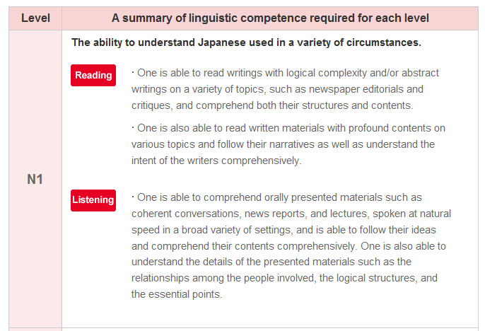

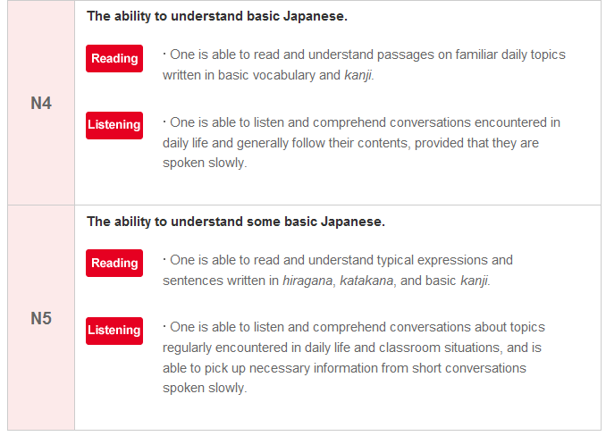

**[Newly established] Positioned at a level bridging the old Level 2 and Level 3 tests.**

**★** If you passed **Level 3 in the old test**, we suggest that you try **N3** next.

**Approximately the same level as the old Level 1 test.**

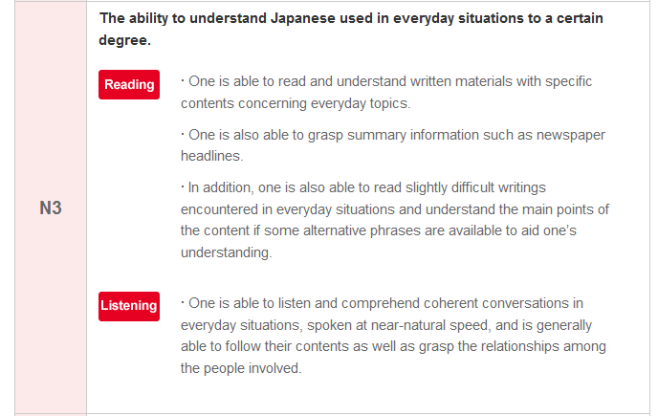

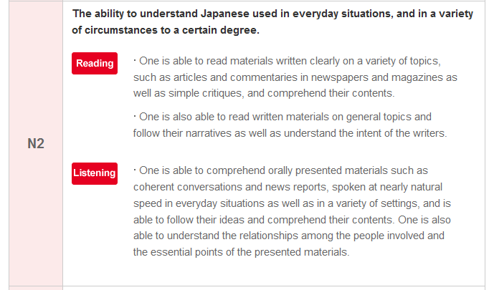

**Approximately the same level as the old Level 3 test.**

**Approximately the same level as the old Level 4 test.**

**Approximately the same level as the old Level 2 test.**

# Horizontal_A_Colour

# Application Form:

# New JLPT Information Sessions (August/September 2011)

# Application forms must be completed in English.

# Incomplete application forms will not be accepted.

|  |  |
| --- | --- |
| applicant’s name (last name, first name) |  |
| level of the session you wish to take | N1 N2 N3 N4 N5  If you are not sure of your level, you may register more than one. |
| the level of JLPT you passed most recently | N1 (/１級\*) N2 (/２級) N3 N4 (/３級)　N5 (/４)  *or* ( ) I have never taken/passed the JLPT before.  \* The numbers in the parentheses indicate the level in the **old** JLPT. |
| home address |  |
| e-mail address |  |
| telephone number |  |
| Optional Questions | |
| How long have you been studying Japanese? | year(s) month(s) |
| name of school(s) where you study Japanese |  |
| name of textbook(s) you currently use |  |
| Have you lived in Japan?  If yes, how long? | Yes. / No.  　　　　　 year(s) month(s) |

The JFT will keep your information confidential. It will be only used to contact you regarding these sessions.