PRESS RELEASE November 25, 2011 No. 665

The Japanese-Language Proficiency Test (JLPT)
About 400,000 learners in the world will take the test on December 4

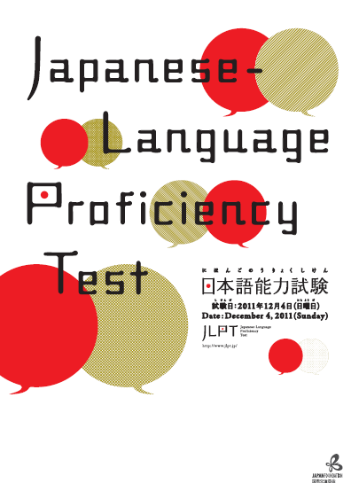
The JLPT, the world’s largest Japanese-language test, is a test for non-native speakers of Japanese and has 27 years of history. Welcoming 6 new test sites (Johor Bahru (MALAYSIA), Monterrey (MEXICO), Quito (ECUADOR), Santiago (CHILE), Edinburgh (U.K.), Vienna (AUSTRIA)), the JLPT will be held in 40 prefectures in Japan and 196 cities in 60 countries and areas overseas on December 4. The Japan Foundation and Japan Educational Exchanges and Services jointly administer the test. The Japan Foundation administers the test overseas in cooperation with local institutions. (In Taiwan, the Japan Foundation and the Interchange Association jointly administer the test.)

【The Japanese-Language Proficiency Test in 2011 (December)】

Test Date: Sunday, December 4, 2011
Test Sites: In Japan: 40 prefectures Overseas: 196 cities in 60 countries/areas
New test sites scheduled for December test in 2011 are
Johor Bahru (MALAYSIA), Monterrey (MEXICO), Quito (ECUADOR),
Santiago (CHILE), Edinburgh (U.K.), Vienna (AUSTRIA)
Levels: N1、N2、N3、N4、N5 （Ｎ１ is the most difficult）
Number of applicants: About 396,000 people （Japan: 76,000 Overseas: 320,000）
※The number of applicants in the July test in 2011 is about 304,000 people (Japan：About 54,000 Overseas：250,000)

The JLPT was revised in 2010. The points of revision are as follows:
（１）Increased focuses on communicative competence
（２）The number of levels was increased from four to five
（３）More accurate measurement of competence with scaled scores
（４）More easier visualization of what you can do in Japanese
（Please see our official worldwide JLPT website (www.jlpt.jp) for more details）

■The Official Worldwide JLPT Website http://www.jlpt.jp/

Contact: Administration of JLPT overseas：The Japan Foundation Center for Japanese-Language Testing
Persons in charge： Kono(Ms.), Kumagai(Mr.), Miyake(Mr.)
Tel： (03)5367-1021 Fax： (03)5367-1025 Email： jlptinfo@jpf.go.jp

Administration of JLPT in Japan： Japan Educational Exchanges and Services
Tel：(03)5454-5215 Fax：(03)5454-5235

